**Development of an Internet of Medical Things (IoMT)-Based Smart Healthcare System**

Project Report submitted in Partial Fulfillment of the Requirements for the degree of Bachelor of Technology

By

**KOMAL GARG (20095054)**

[komal.student.ece20@itbhu.ac.in](mailto:komal.student.ece20@itbhu.ac.in)

**ROHIT KUMAR GAUTAM (20095093)**

rohikumar.gautam.ece20@itbhu.ac.in

**DEBASISH CHAKRABORTY (20095131)**

[debasish.chakraborty.cd.ece20@itbhu.ac.in](mailto:debasish.chakraborty.cd.ece20@itbhu.ac.in)

Under the Guidance of

**DR. PRIYA RANJAN MUDULI**

[prmuduli.ece@iitbhu.ac.in](mailto:prmuduli.ece@iitbhu.ac.in)



**Department of Electronics Engineering**

**INDIAN INSTITUTE OF TECHNOLOGY (BHU) VARANASI**

**Varanasi 221005, India**

Certificate By The Supervisor

This is to certify that the dissertation entitled “Development of an Internet of Medical Things (IoMT)-Based Smart Healthcare System” submitted by **Komal Garg (20095054)**, **Rohit Kumar Gautam (20095093)**, and **Debasish Chakraborty (200950131)**, to the Department of Electronics Engineering, Indian Institute of Technology (Banaras Hindu University), Varanasi, in partial fulfillment of the requirements for the award of the degree “Bachelor of Technology” in Electronics Engineering is an authentic work carried out at Department of Electronics Engineering, Indian Institute of Technology (Banaras Hindu University), Varanasi by them under my supervision and guidance on the concept covered by the project grant as acknowledged.

# 

# 

# 

# 

# 

# 

**Signature Of Supervisor**

Prof. Priya Ranjan Muduli

Department of Electronics Engineering

IIT (BHU) Varanasi

# 

Certificate

This is to certify that this project report “Development of an Internet of Medical Things (IoMT)-Based Smart Healthcare System”is submitted by **Komal Garg**, **Rohit Kumar Gautam**, and **Debasish Chakraborty**, who carried out the project work under the supervision of **Prof. Priya Ranjan Muduli**.

We approve this project for submission of the B.Tech Project, IIT(BHU) Varanasi.

Signature of the students:

**Komal Garg Rohit Kumar Gautam**

**Debasish Chakraborty**

# 

Declaration

We hereby declare that the work presented in this thesis titled “Development of an Internet of Medical Things (IoMT)-Based Smart Healthcare System” is an authentic record of our own work carried out at the Department of Electronics Engineering, Indian Institute of Technology (Banaras Hindu University), Varanasi as requirement for the award of degree of Bachelors of Technology in Electronics Engineering, submitted in the Indian Institute of Technology (Banaras Hindu University), Varanasi (U.P) under the supervision of **Dr. Priya Ranjan Muduli**, Department of Electronics Engineering, Indian Institute of Technology (Banaras Hindu University), Varanasi. It does not contain any part of the work, which has been submitted for the award of any degree either in this Institute or in other University/Deemed University without proper citation.

# 

Acknowledgement

It gives us immense pleasure to express our deepest sense of gratitude and sincere thanks to our highly respected and esteemed guide, **Dr. Priya Ranjan Muduli**, for his valuable guidance, encouragement, and help in accomplishing this work.

His useful suggestions for this whole project are sincerely acknowledged. We would also like to express our sincere thanks to all others who helped us directly or indirectly during this project work.

# 

# 

# 

# 

# 

# 

# 

# 

# 

# 

# 

**Students Name:** **Date:** 22-11-2023

Komal Garg

Rohit Kumar Gautam

Debasish Chakraborty

# 

Abstract

This project focuses on the real-time analysis of Photoplethysmogram (PPG) signals to estimate heart rate and body temperature while also developing a machine learning model for predicting blood pressure. PPG signals are obtained from wearable sensors, and the project employs various signal processing techniques and machine learning algorithms to extract valuable health metrics. The results provide a comprehensive assessment of an individual's cardiovascular health and body temperature in real-time, allowing for early detection of health issues.

# 

Index

**Introduction 1**

**Novelty and Contribution 1**

Objectives 1

**Literature Review 3**

Common Terms and Definitions 3

ECG and PPG Wave 4

Existing Features 5

Specifications Table 6

MAX30102 Heart Rate and Oximeter Sensor 6

Arduino Nano 33 BLE 6

**Detailed Methodology 7**

Hardware Specifications 7

MAX30102 Heart Rate and Oximeter Sensor 7

Arduino Nano 33 BLE 7

Connections 8

Data Collection 8

Data Output 9

Various Libraries Used 10

Web Application(GUI) 11

Blood Pressure Prediction Model 14

Dataset 14

Exploratory Data Analysis 14

Model Building and Evaluation 15

Linear Regression 15

Model Description 15

Results 15

Neural Network (Deep Learning) Model 16

Model Architecture 16

Loss Function and Optimization 16

Training Process 17

Results 17

Conclusion 18

**Challenges Faced 19**

**Future Aspects 19**

**References and Bibliography 20**

| List Of Figures   * Figure 1. Non Invasive PPG * Figure 2. System Architecture * Figure 3. ECG and PPG Wave * Figure 4. MAX30102 Heart Rate and Oximeter Sensor * Figure 5. Arduino Nano 33 BLE * Figure 6. Connection Of Arduino with Sensor * Figure 7. ECG Plot * Figure 8. Data Received * Figure 9. Login Page * Figure 10. SignUp Page * Figure 11. Patients Detail Page * Figure 12. Code Snippet * Figure 13. PPG Plot * Figure 14. PPG and ECG graphs * Figure 15. Blood Pressure Graph * Figure 16. Cross-correlated resultant graph of PPG and BP * Figure 17. Linear Regression BP Predicted values * Figure 18. Model Architecture of Neural Network Model * Figure 19. Training Process Results for Neural Network Model * Figure 20. Neural Network BP Predicted values |
| --- |

# 

# Introduction

In the era of rapid technological advancements, the importance of health monitoring has reached new heights. Continuous tracking of vital signs, such as heart rate, body temperature, and blood pressure, has become crucial for early detection of health issues and overall well-being.

Health monitoring traditionally involves occasional visits to healthcare facilities for check-ups. However, the advent of wearable technology and IoMT has opened avenues for real-time, non-invasive monitoring. The focus of our project lies in the real-time analysis of Photoplethysmogram (PPG) signals, obtained from wearable sensors, to estimate heart rate and body temperature. Additionally, we employ machine learning algorithms to predict blood pressure, providing a holistic approach to cardiovascular health monitoring.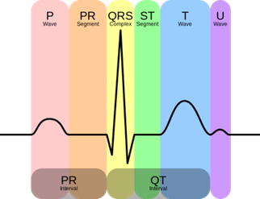

*Figure 1. Non-Invasive PPG*

# Novelty and Contribution

The uniqueness of this project is found in its fusion of real-time signal analysis, and machine learning for the ongoing monitoring of health. By combining these elements, the system facilitates early detection of health issues, promotes remote health management, and aligns with the growing trend of personalized telehealth solutions.

## Objectives

1. **Real-Time PPG Signal Analysis**

The project introduces a robust system for real-time analysis of PPG signals. Traditional health monitoring methods often rely on sporadic measurements, whereas our system provides continuous insights into vital signs. The application of signal processing techniques for estimating heart rate and body temperature from PPG data ensures a comprehensive understanding of cardiovascular health.

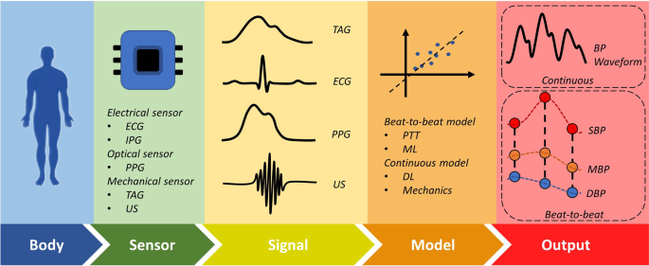*Figure 2. System Architecture*

1. **Machine Learning Model for Blood Pressure Prediction**

The incorporation of a machine learning model for blood pressure prediction adds a layer of intelligence to the system. While existing technologies may focus on individual vital signs, our project takes a holistic approach by predicting blood pressure through advanced algorithms. This predictive capability enhances early detection of cardiovascular issues, setting it apart from conventional monitoring devices.



1. **Web Application for User-Friendly Interface**

The development of a user-friendly web application further enhances the accessibility and usability of the system. Users can seamlessly interact with the health monitoring data, visualize real-time PPG signal analyses, and input additional information. The integration of user authentication and data input/output functionalities contributes to a comprehensive user experience.



# Literature Review

## Common Terms and Definitions

* **Internet of Medical Things (IoMT):** The interconnected network of medical devices and systems that communicate and share data to enhance healthcare.
* **Photoplethysmogram (PPG):** An optical measurement technique capturing blood volume changes, commonly used for monitoring heart rate and oxygen saturation.
* **Machine Learning (ML):** A subset of artificial intelligence (AI) focused on developing algorithms that enable computers to learn from data and make predictions.
* **Blood Pressure (BP):** The force exerted by circulating blood against artery walls, measured in millimeters of mercury (mmHg) as systolic over diastolic pressure.
* **Wearable Technology:** Devices worn on the body, often equipped with sensors for health data monitoring.
* **Web Application:** A software application accessed through a web browser, facilitating user interaction over the internet.
* **Bluetooth Low Energy (BLE):** Wireless communication technology used for short-range communication in devices like wearables.

## ECG and PPG Wave

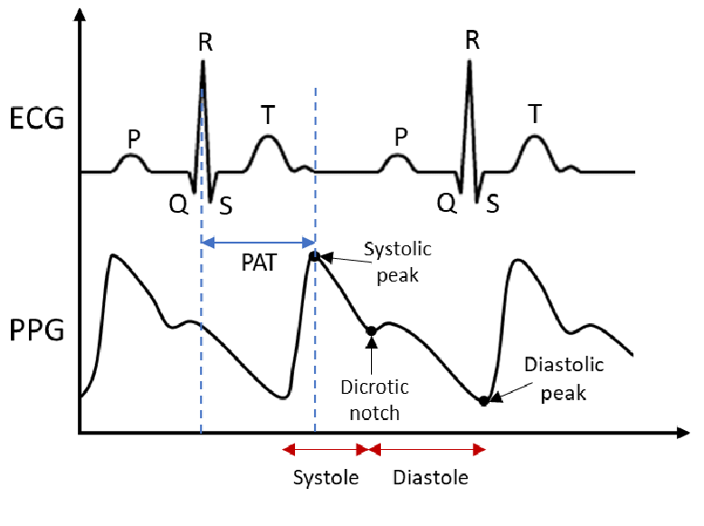

*Figure 3. ECG and PPG Wave*

The components of an **electrocardiogram (ECG)** wave are comprised of:

* P wave : atrial depolarization
* QRS wave : ventricles depolarization
* T wave : repolarization of ventricles
* U wave

The **Photoplethysmogram (PPG)** waveform consists of several distinct regions that correspond to different phases of the cardiac cycle. Here's a brief explanation of these regions:

* Baseline (Dicrotic Notch): The baseline is the flat line at the bottom of the PPG waveform. The dicrotic notch is a small upward deflection typically seen in this region, representing the closure of the aortic valve.
* Pulse Wave: The rising edge of the waveform is called the pulse wave. It corresponds to the ventricular contraction (systole) and the ejection of blood into the arterial system.
* Trough: Following the pulse wave, there is a descending portion called the trough. It represents the relaxation of the ventricles (diastole) when the heart is at rest.
* Incisura: The small notch seen after the peak of the pulse wave is known as the incisura. It occurs when the aortic valve briefly closes, preventing blood from flowing back into the heart.

## Existing Features

* **Ambulatory Monitoring Systems:**
  + Features: Wearable bulky devices designed for continuous monitoring, often using PPG, ECG, and other sensors.
  + Limitations: Power consumption, signal quality, and comfort may pose challenges.
* **Standard 12-Lead ECG Machine:**
  + Features: This is the most common and traditional method for ECG measurement, which involves attaching electrodes to the patient's chest, arms, and legs to record the electrical activity of the heart.
  + Limitations: These ECG devices are often bulky, expensive, and require skilled professionals to operate them
* **Single-Feature PPG Analysis:**
  + Features: Relies on a singular PPG signal feature, potentially oversimplifying the complex relationship between PPG dynamics and blood pressure.
  + Limitation: Relying solely on a single feature of the PPG signal, such as peak detection or amplitude, may not capture the complexity of cardiovascular dynamics, leading to less accurate predictions.
* **Static Blood Pressure Models:**
  + Features: Assumes a static or linear variation of blood pressure over time, potentially overlooking the dynamic and individualized nature of blood pressure changes.
  + Limitation: Models that assume blood pressure to be static or vary linearly with time may not adequately represent the dynamic nature of blood pressure changes, particularly in response to physiological stressors.

## 

## Specifications Table

### **MAX30102 Heart Rate and Oximeter Sensor**

| LED peak wavelength | 660nm/880nm |
| --- | --- |
| LED power supply voltage | 3.3~5V |
| Detection signal type | light reflection signal (PPG) |
| Output signal interface | I2C interface |
| Communication interface voltage | 1.8~3.3V~5V |
| Supply Current | 600 µA |

### **Arduino Nano 33 BLE**

### 

### 

| Microcontroller | nRF52840 |
| --- | --- |
| Operating Voltage | 3.3V |
| Input Voltage (limit) | 21V |
| DC Current per I/O Pin | 15 mA |
| Clock Speed | 64MHz |
| Digital Input / Output Pins | 14 |

# 

# Detailed Methodology

## Hardware Specifications

### **MAX30102 Heart Rate and Oximeter Sensor**

The MAX30102 Heart Rate and Oximeter Sensor is a compact and highly integrated sensor module designed for monitoring heart rate and oxygen saturation (SpO2) levels in the blood. It is commonly used in various applications, including wearable fitness trackers, medical devices, and healthcare monitoring systems. The MAX30102 sensor is capable of non-invasively measuring the user's heart rate and blood oxygen levels by shining red and infrared light through the skin and detecting the light that is absorbed by hemoglobin. It uses the principle of photoplethysmography (PPG) to obtain these vital signs.

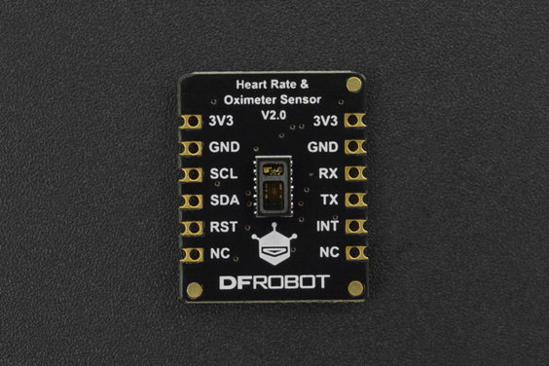

*Figure 4. MAX30102 Heart Rate and Oximeter Sensor*

### **Arduino Nano 33 BLE**

The Arduino Nano 33 BLE is a compact and versatile microcontroller board developed by Arduino. It is part of the Arduino Nano family and is equipped with Bluetooth Low Energy (BLE) connectivity. The Nano 33 BLE is equipped with a 9-axis inertial measurement unit (IMU), which consists of a three-axis accelerometer, a three-axis gyroscope, and a three-axis magnetometer. This feature makes the Nano 33 BLE an excellent option for advanced robotics experiments, fitness trackers, digital compass applications, and more.

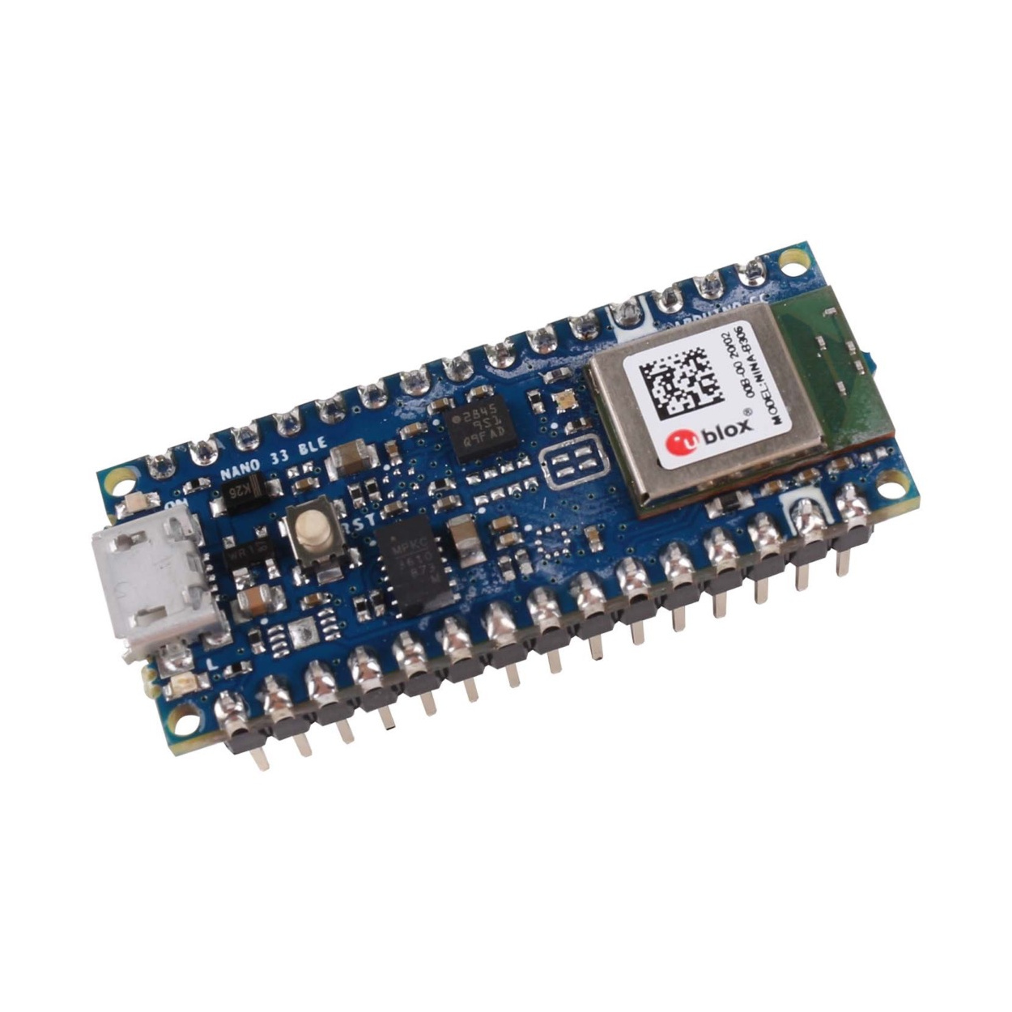

*Figure 5. Arduino Nano 33 BLE*

## Connections

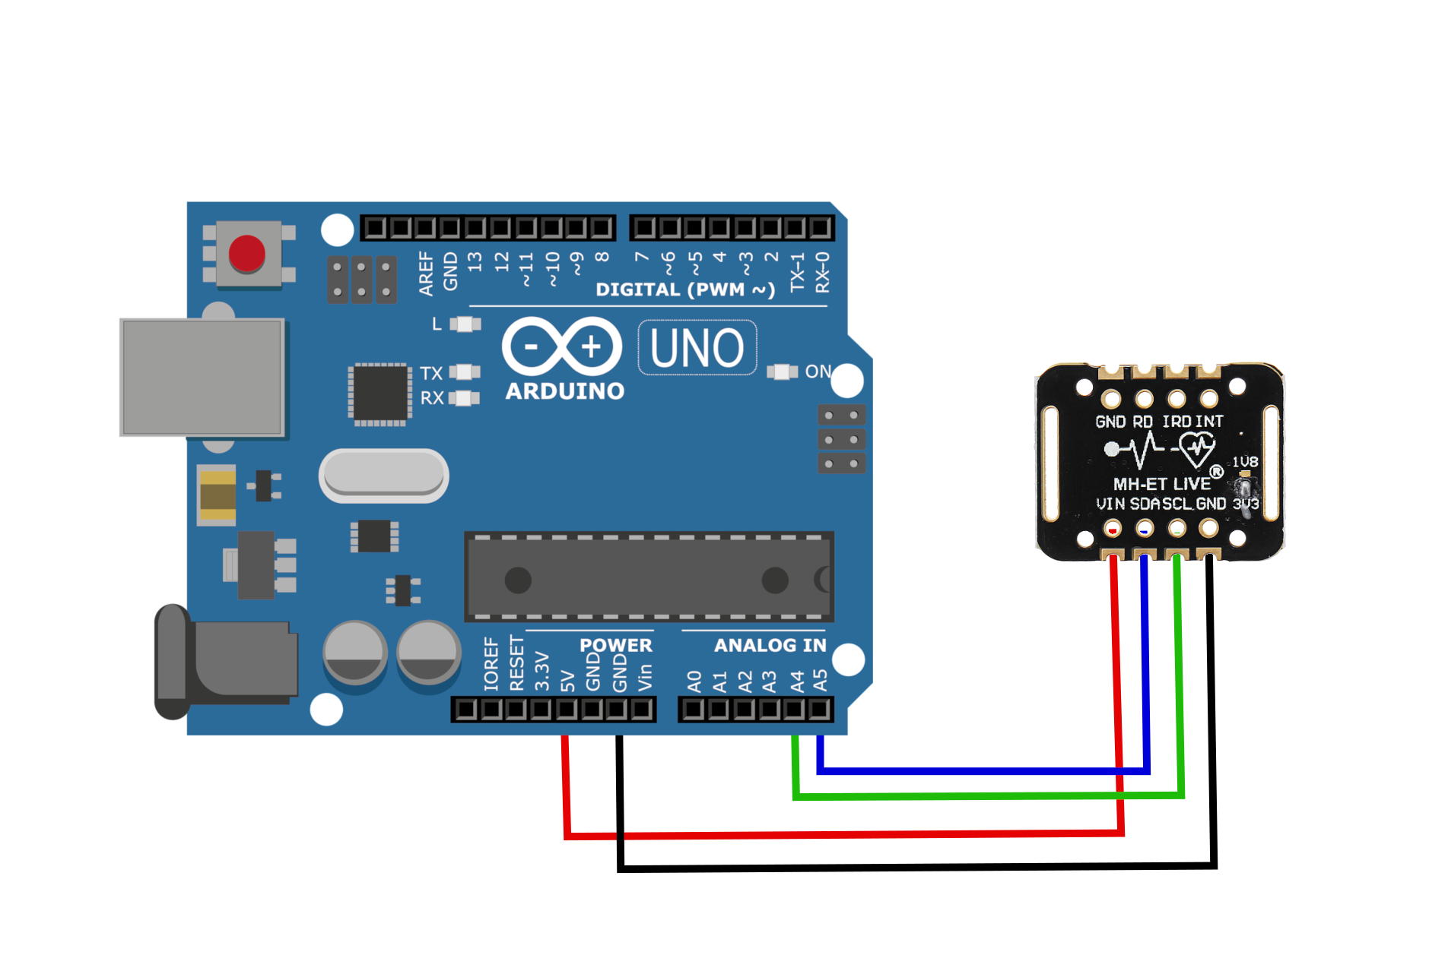

*Figure 6. Connection Of Arduino with Sensor*

## Data Collection

PPG signals are collected from wearable sensors worn by the user. Simultaneously, heart rate data is collected using PPG signals.

We will connect Arduino Nano 33 BLE with MAX30102 Heart Rate and Oximeter Sensor. To start, establish a connection by attaching the VCC pin to your power source, ensuring it's within the range of 3V to 5V, which aligns with your microcontroller's logic voltage. In the case of most Arduinos, this voltage is 5V, while for devices using 3.3V logic, a 3.3V power source should be used. Next, establish a common ground by connecting the GND.

Proceed by linking the SCL pin to the I2C clock pin and the SDA pin to the I2C data pin on your Arduino board. It's essential to be aware that different Arduino boards have distinct I2C pin layouts, so you should refer to the specific board's documentation for the correct pin connections. In Arduino boards following the R3 layout, the SDA (data line) and SCL (clock line) can be found on the pin headers near the AREF pin and are often labeled as A5 (SCL) and A4 (SDA).

## Data Output

In order to make it user-friendly and accessible to public, we have deployed it into a **web application**. The information is displayed on a web application using the p5.ble.js JavaScript library. p5.ble.js is a JavaScript library designed to facilitate communication between p5 sketches and BLE (Bluetooth Low Energy) devices. It leverages the Web Bluetooth API and simplifies the setup process with a set of straightforward functions. This library is valuable for developing personalized web applications that can interact with your BLE-enabled circuit. Subsequently, we will conduct an analysis of the data to continuously and non-invasively monitor essential health parameters.

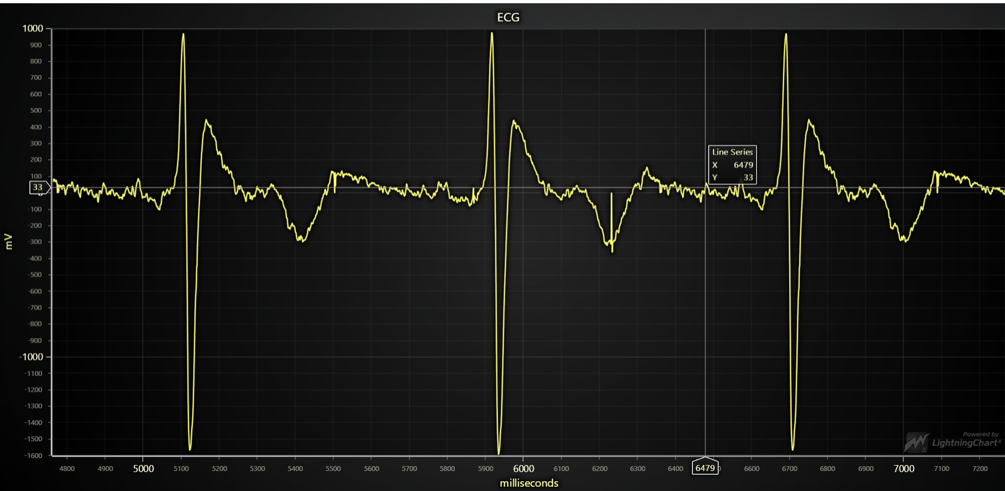

*Figure 7. ECG Plot*

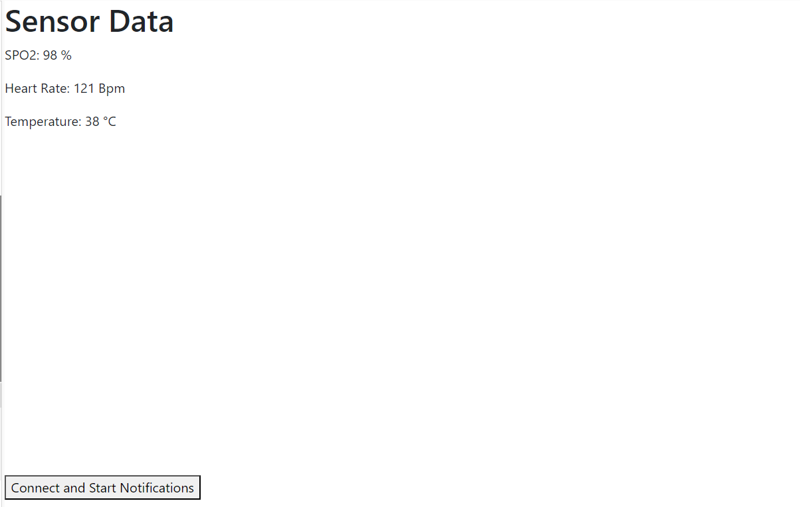

*Figure 8. Data Received*

## Various Libraries Used

* **DFRobot_BloodOxygen_S:-** This Arduino library provides sample codes to get the current heart rate and oxygen saturation of users. To use this library, first download the library file, paste it into the \Arduino\libraries directory, then open the examples folder and run the demo in the folder.
* **p5.ble.js:-** The p5.ble.js library is a JavaScript library designed to enable communication between p5.js sketches and Bluetooth Low Energy (BLE) devices. It simplifies the process of working with BLE devices in web applications**.**  With p5.ble.js, you can request and connect to nearby Bluetooth devices, read/write Bluetooth characteristics, start/stop notifications. To get started, you need to include the p5.ble.js library in your web application by linking to it in your HTML file. You also need to create a p5 sketch that will handle the BLE interactions.
* **LightningChart JS:-** It is a powerful library designed for building data visualization applications that are not only interactive but also deliver exceptional performance. This tool equips developers with high-level components, making it easy to integrate highly efficient charts and graphs into their web applications without extensive effort. LightningChart JS can be easily obtained through methods such as NPM installation or by using a CDN service like jsdelivr. In the context of the current application, it is being employed to plot ECG (electrocardiogram) signals.

## Web Application(GUI)

* **User Authentication**: User authentication features were implemented using Streamlit's inbuilt user management or custom authentication scripts. User data, including usernames and hashed passwords, were stored in a MySQL database to ensure secure user management.
* **Front-End Design**: The web application's front-end was designed to provide an intuitive user interface for sign-up, login, and real-time PPG signal visualization. Streamlit's widgets and custom CSS were used to create a visually appealing layout.
* **Database Integration**: A MySQL database was chosen to store user authentication information. The database was set up with tables to manage user accounts, which included user IDs, usernames, and hashed passwords.
* **Data Input and Output**: The web application allows users to input PPG data for real-time analysis and, if needed, to retrieve historical PPG data stored in the database.

The web page starts with two routes :

1. **Signup** - for new users

2. **login** - for existing users

Followed by other activities e.g. “Add patient record” etc.

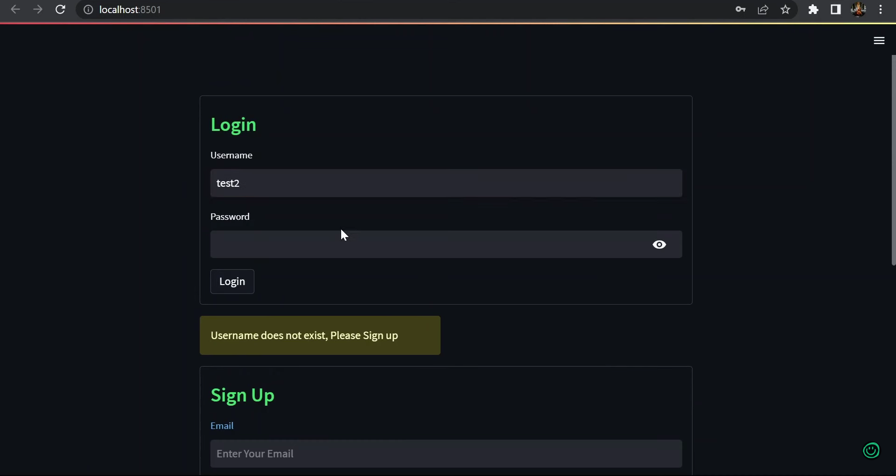

*Figure 9. Login Page*

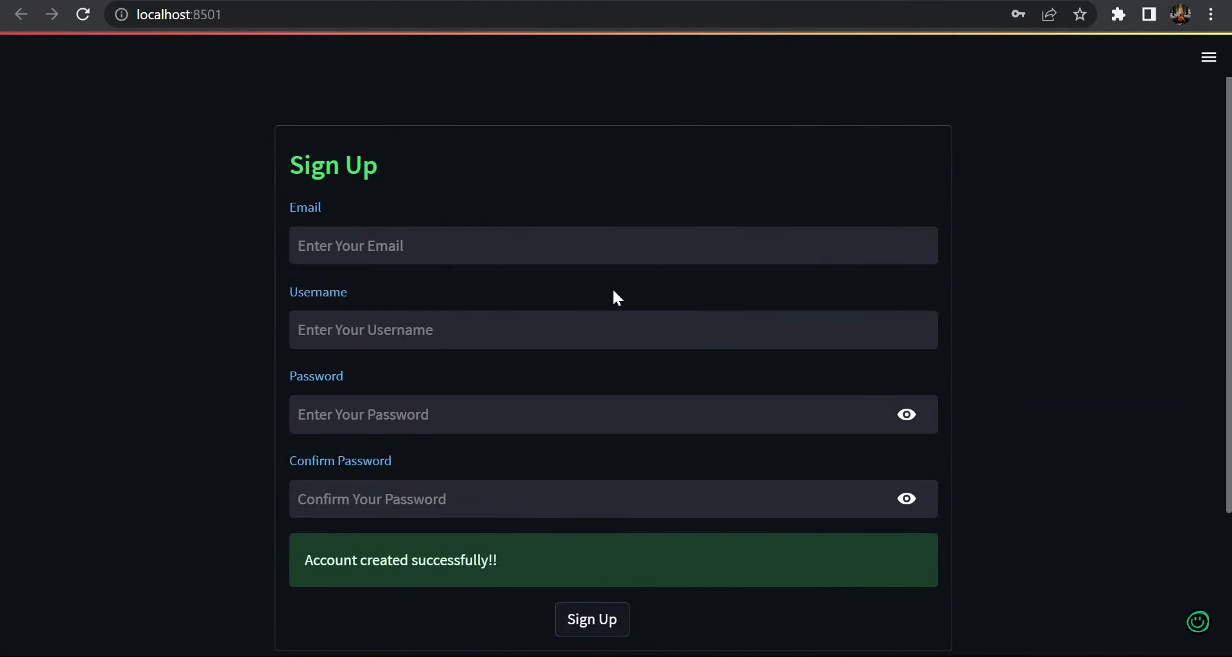

*Figure 10. SignUp Page*

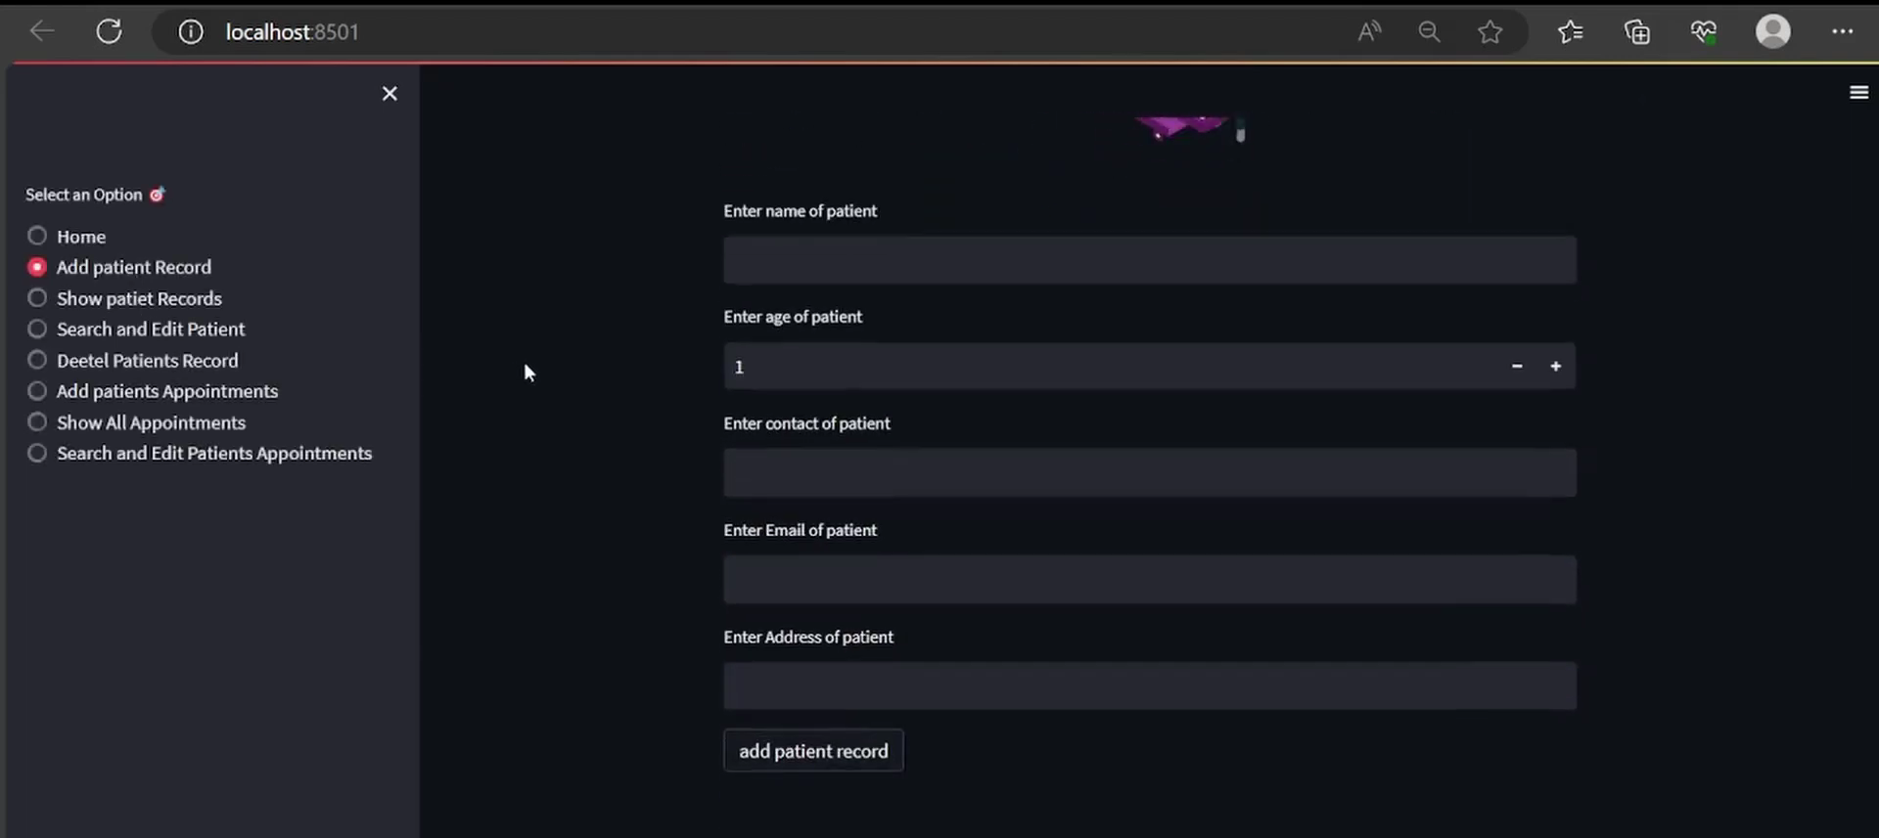

*Figure 11. Patients Detail Page*

Approach for Detecting and Showing PPG graph in web application

* **Library Integration**: The PPG-beats library, written in MATLAB, has to be integrated into the web application using Python's subprocess or any appropriate method. PPG-beats provides a range of algorithms for detecting heartbeats in photoplethysmogram (PPG) signals.
* **Data Acquisition**: Real-time PPG signals have to be acquired either through external devices or simulated PPG data, depending on the testing setup. The PPG signal data was passed to the PPG-beats algorithms for analysis.
* **Real-Time Display**: The detected heartbeats and PPG signal were displayed in real-time on the web application using Streamlit's interactive plotting features. Users could observe the processed PPG signals and monitor their heartbeats.

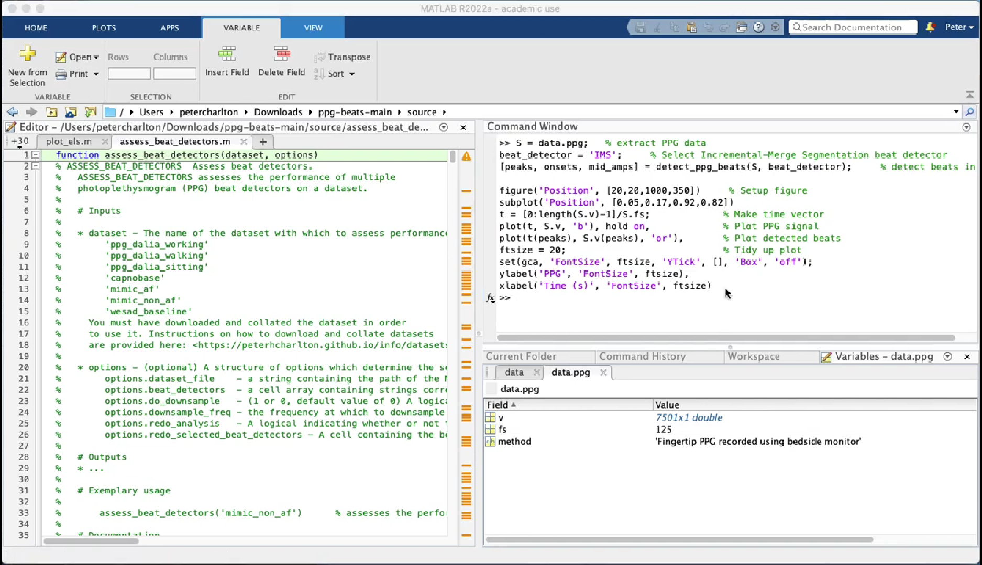

*Figure 12. Code Snippet*

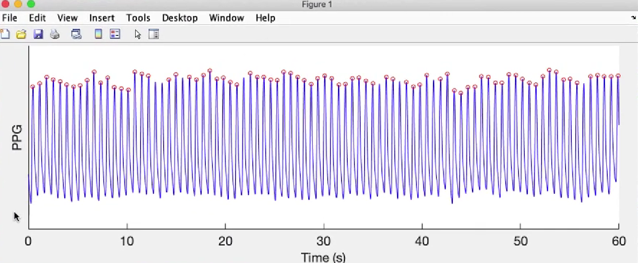

*Figure 13. PPG Plot*

## Blood Pressure Prediction Model

### Dataset

**Link** : <https://www.kaggle.com/datasets/mkachuee/BloodPressureDataset>

This dataset offers high-quality and valid data suitable for developing non-invasive algorithms to estimate blood pressure without the need for a cuff. The data is stored in MATLAB files (.mat), and it consists of raw signals for electrocardiogram (ECG), photoplethysmograph (PPG), and arterial blood pressure (ABP). These signals are organized as cell arrays or matrices, with each cell representing a specific part of the recorded data. Within each matrix, individual rows correspond to distinct signal channels:

* **PPG signal**, sampled at 125Hz, sourced from the fingertip's photoplethysmograph.
* **ABP signal**, sampled at 125Hz, representing invasive arterial blood pressure in millimeters of mercury (mmHg).
* **ECG signal**, sampled at 125Hz, originating from channel II of the electrocardiogram.

### Exploratory Data Analysis

Before building predictive models, we visualize and analyze the data to gain insights into the relationships between the signals. We calculate the cross-correlation between PPG and BP signals to identify any potential dependencies.

We also visualize sample PPG, ECG, and BP signals, which helps us understand their characteristics and relationships. Additionally, we plot SBP and DBP to observe variations over time.

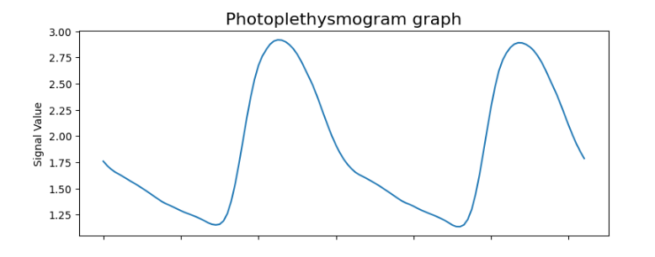 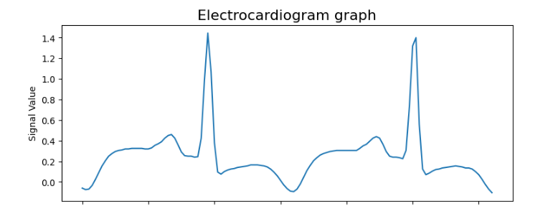

*Figure 14. PPG and ECG graphs*

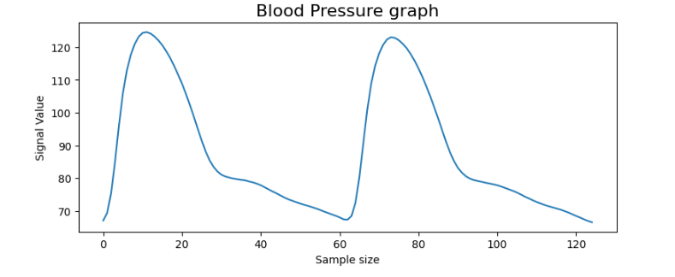

*Figure 15. Blood Pressure Graph*

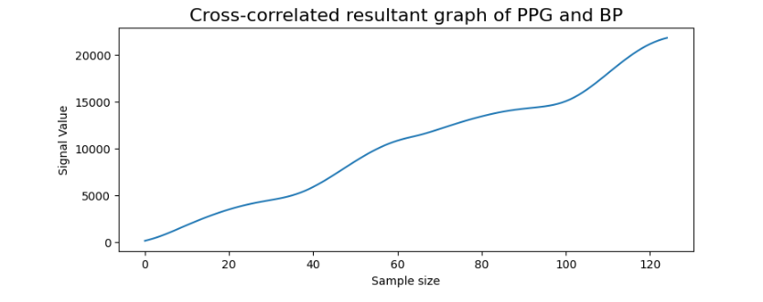

*Figure 16. Cross-correlated resultant graph of PPG and BP*

### 

### Model Building and Evaluation

#### Linear Regression

##### Model Description

We start by building a simple Linear Regression model. The dataset is split into training and testing sets. A 5-fold cross-validation is performed on the training data to assess the model's performance. Mean squared error is used as the evaluation metric.

##### Results

The average RMSE (Root Mean Squared Error) over the 5 folds is found to be 27.34512297194153. This metric measures the error in predicting BP values.

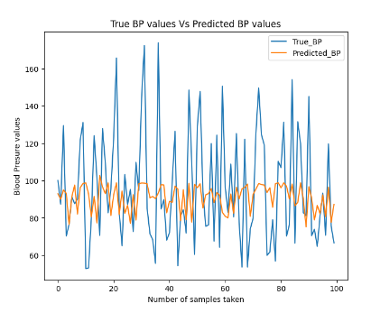

*Figure 17. Linear Regression BP Predicted values*

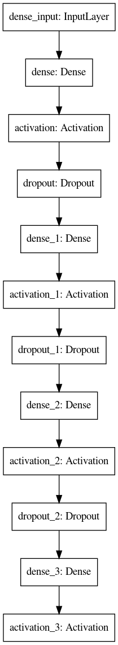

#### Neural Network (Deep Learning) Model

##### Model Architecture

The deep learning model used in our project is a feedforward neural network. It consists of multiple layers, including dense (fully connected) layers, activation functions, and dropout layers. Here's a breakdown of the architecture:

**Input Layer:** The input layer has as many neurons as there are features in our input data which basically corresponds to the PPG signal features.

**Dense Layers:** The model includes several dense layers, which are responsible for learning complex patterns in the input data.

* Layer 1 (1024 neurons): This layer has 1024 neurons and uses the ReLU (Rectified Linear Unit) activation function. ReLU is a common choice for activation functions in deep learning models.
* Layer 2 (512 neurons): This layer has 512 neurons and also uses ReLU activation.
* Layer 3 (64 neurons): The third dense layer has 64 neurons and utilizes ReLU activation.

**Dropout Layers:** Dropout layers are introduced to prevent overfitting. They randomly drop a certain percentage of neurons during training to enhance generalization.

* Dropout Layer 1 (50% dropout): The first dropout layer has a dropout rate of 50%, meaning half of the neurons are dropped during each training iteration.
* Dropout Layer 2 (50% dropout): Similarly, the second dropout layer has a 50% dropout rate.
* Dropout Layer 3 (25% dropout): The third dropout layer has a lower dropout rate of 25%.

**Output Layer:** The output layer typically has one neuron for regression problems, as in your case. The activation function is set to 'linear' since you want the model to predict continuous values (blood pressure).

##### Loss Function and Optimization

For this regression problem, the loss function used is 'Huber loss.' Huber loss is less sensitive to outliers compared to mean squared error (MSE) and is a suitable choice for blood pressure estimation.

The model is optimized using the Adam optimizer with a learning rate of 0.001. Adam is an efficient optimizer for training neural networks, and the learning rate determines how quickly the model adapts to the data.

##### Training Process

The training process involves feeding the neural network with input data (PPG features) and target labels (actual blood pressure values) and iteratively updating the model's parameters to minimize the Huber loss.

##### Results

The training process for the neural network model showed the following mean absolute error (MAE) values during the five training epochs:

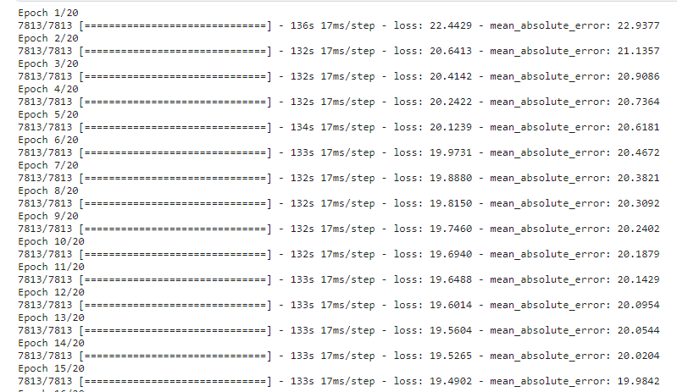

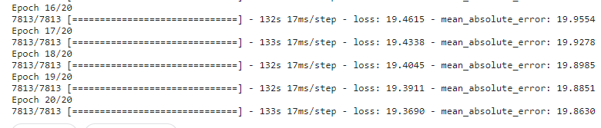

*Figure 19. Training Process Results for Neural Network Model*

Neural Net RMSE: 25.984938312500034

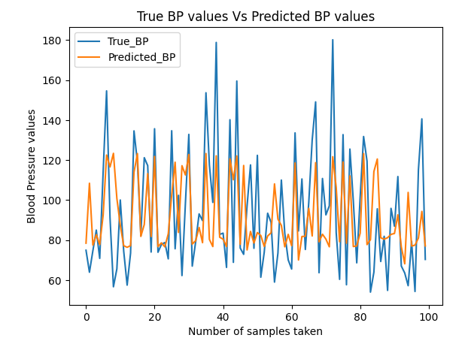

*Figure 20. Neural Network BP Predicted values*

#### Conclusion

In summary, both the Linear Regression and Neural Network models exhibited similar RMSE values on the test set, with the Neural Network model showcasing the potential to capture non-linear relationships in the data. Given its ability to model complex data patterns and adapt to various scenarios, the Neural Network model is preferable for blood pressure prediction. Further refinements and hyperparameter tuning can enhance its performance, making it a promising choice for more accurate and robust predictions.

# Challenges Faced

* **Sensor Integration and Communication:** Establishing a reliable connection between the Arduino Nano 33 BLE and the sensor, ensuring proper data acquisition, and handling communication issues.
* **Web Application Development:**  Designing and implementing a user-friendly web application to display real-time sensor data, including challenges in UI/UX design and responsiveness.
* **Real-Time Data Visualization:** Achieving real-time data visualization on the web application, dealing with latency issues, and ensuring a smooth user experience.
* **Machine Learning Model Integration:** Integrating a machine learning model for blood pressure prediction into the web application, ensuring seamless communication between the frontend and the model.
* **Model Accuracy and Validation:** Achieving accurate predictions with the machine learning model, addressing issues related to overfitting, underfitting, or model validation.
* **Data Security and Privacy:** Ensuring data security and privacy, especially when dealing with health-related data, and addressing concerns related to data transmission and storage.
* **User Education and Interaction:** Educating users on how to use the web application effectively and interpret the displayed data, providing a seamless user experience.

# Future Aspects

* **Integration of Machine Learning Model:** The ongoing development involves the creation of a machine learning model dedicated to blood pressure prediction. Future work will focus on seamlessly integrating this machine learning model into the web application.
* **Model Calibration and Fine-Tuning:** Future efforts will be directed towards periodic model calibration and fine-tuning to enhance predictive accuracy, incorporating user feedback and new data.
* **Feature Expansion:** The potential expansion of features within the machine learning model is being explored, including additional health indicators or refinements to enhance overall predictive capabilities.

# References and Bibliography

1. Muduli, P. R., and Mukherjee, A.: “A Robust Estimator-based Nonlinear Filtering Approach to Piecewise Biosignal Reconstruction", IEEE Trans. Instrumentation and Measurement, 69(2), pp. 362-370 (2020).
2. Muduli, P. R., and Mukherjee, A.: “A Moreau Envelope-based Nonlinear Filtering Approach to Denoising Physiological Signals", IEEE Trans. Instrumentation and Measurement, 69 (4), pp. 1041-1050 (2020).
3. M. R. Khan Menon, M. M. Rahman and H. -G. Ryu, "ECG(electrocardiogram) Digital Signal Processing for the Biomedical Applications," 2021 8th International Conference on Computer and Communication Engineering (ICCCE), Kuala Lumpur, Malaysia, 2021, pp. 214-217, doi: 10.1109/ICCCE50029.2021.9467137.
4. J. Rumbut, H. Fang, S. Carreiro, D. Smelson and E. Boyer, "An Overview of Wearable Biosensor Systems for Real-Time Substance Use Detection," in IEEE Internet of Things Journal, vol. 9, no. 23, pp. 23405-23415, 1 Dec.1, 2022, doi: 10.1109/JIOT.2022.3207090.
5. Salem M, Elkaseer A, El-Maddah IAM, Youssef KY, Scholz SG, Mohamed HK. Non-Invasive Data Acquisition and IoT Solution for Human Vital Signs Monitoring: Applications, Limitations and Future Prospects. Sensors (Basel). 2022 Sep 1;22(17):6625. doi: 10.3390/s22176625. PMID: 36081081; PMCID: PMC9460364.
6. Yeh LR, Chen WC, Chan HY, Lu NH, Wang CY, Twan WH, Du WC, Huang YH, Hsu SY, Chen TB. Integrating ECG Monitoring and Classification via IoT and Deep Neural Networks. Biosensors (Basel). 2021 Jun 8;11(6):188. doi: 10.3390/bios11060188. PMID: 34201215; PMCID: PMC8226863.
7. Blood Pressure Estimation from Photoplethysmogram Using a Spectro-Temporal Deep Neural Network Gašper Slapniˇcar 1,*, Nejc Mlakar 2 and Mitja Luštrek 1,3
8. Handler, J. The Importance of Accurate Blood Pressure Measurement. Perm. J. 2009, 13, 51–54.
9. Assessment of Non-Invasive Blood Pressure Prediction from PPG and rPPG Signals Using Deep Learning, Fabian Schrumpf 1,* , Patrick Frenzel 1, Christoph Aust 2 , Georg Osterhoff 2 and Mirco Fuchs 1.
10. Ding, X.R.; Zhao, N.; Yang, G.Z.; Pettigrew, R.I.; Lo, B.; Miao, F.; Li, Y.; Liu, J.; Zhang, Y.T. Continuous Blood Pressure Measurement From Invasive to Unobtrusive: Celebration of 200th Birth Anniversary of Carl Ludwig. IEEE J. Biomed. Health Inform. 2016, 20, 1455–1465.
11. Blood Pressure Morphology Assessment from Photoplethysmogram and Demographic Information Using Deep Learning with Attention Mechanism, Nicolas Aguirre 1,2,* , Edith Grall-Maës 2 , Leandro J. Cymberknop 1 and Ricardo L. Armentano 1.
12. Ms. R. Hinduja, Ms. M. Krishna Varsha, 0, Low Power Wearable ECG Monitoring, INTERNATIONAL JOURNAL OF ENGINEERING RESEARCH & TECHNOLOGY (IJERT) Confcall – 2018 (Volume 06 – Issue 14),
13. Yeh, Li-Ren & Chen, Wei-Chin & Chan, Hua-Yan & Lu, Nan-Han & Wang, Chi-Yuan & Twan, Wen-Hung & Du, Wei-Chang & Huang, Yung-Hui & Hsu, Shih-Yen & Chen, Tai-Been. (2021). Integrating ECG Monitoring and Classification via IoT and Deep Neural Networks. Biosensors. 11. 188. 10.3390/bios11060188.
14. Xu, Guangyu. (2020). IoT-Assisted ECG Monitoring Framework With Secure Data Transmission for Health Care Applications. IEEE Access. PP. 1-1. 10.1109/ACCESS.2020.2988059.
15. Islam, Sheikh Md. Rabiul & Hossain, Akram & Abdullah, Asif. (2022). Real-Time Acquisition and Classification of Electrocardiogram Signal. Journal of Engineering Research and Sciences. 1. 8-15. 10.55708/js0111002.
16. Su, P.; Ding, X.R.; Zhang, Y.T.; Liu, J.; Miao, F.; Zhao, N. Long-term blood pressure prediction with deep recurrent neural networks. In Proceedings of the 2018 IEEE EMBS International Conference on Biomedical & Health Informatics (BHI), Las Vegas, NV, USA, 4–7 March 2018; pp. 323–328, doi:10.1109/BHI.2018.8333434.
17. Chan, K.W.; Hung, K.; Zhang, Y.T. Noninvasive and cuffless measurements of blood pressure for telemedicine. In Proceedings of the 23rd Annual International Conference of the IEEE Engineering in Medicine and Biology Society, Istanbul, Turkey, 25–28 October 2001; pp. 3592–3593.
18. Luong, M.T.; Pham, H.; Manning, C.D. Effective Approaches to Attention-based Neural Machine Translation. arXiv 2015,arXiv:1508.04025.
19. Chowdhury, M.H.; Shuzan, M.N.I.; Chowdhury, M.E.H.; Mahbub, Z.B.; Uddin, M.M.; Khandakar, A.; Reaz, M.B.I. Estimating Blood Pressure from the Photoplethysmogram Signal and Demographic Features Using Machine Learning Techniques. Sensors 2020, 20, 3127.
20. Chan, K.; Hung, K.; Zhang, Y. Noninvasive and cuffless measurements of blood pressure for telemedicine. In Proceedings of the 23rd Annual International Conference of the IEEE Engineering in Medicine and Biology Society, Istanbul, Turkey, 25–28 October 2001; Volume 4, pp. 3592–3593.
21. KyeonghyeGuk, Gaon Han, Jaewoo Lim, Keunwon Jeong, Taejoon Kang, Eun- Kyung Lim and Juyeon Jung. 2019. Evolution of Wearable Devices with Real-Time Disease Monitoring for Personalized Healthcare. Nanomaterials
22. Priya B, Rajendran S, Bala R and Gobbi R. 2009. Remote Wireless Health Monitoring Systems IEEE Conference on Innovative Technologies in Intelligent Systems and Industrial Applications (CITISIA).
23. Nur Hudha Wijaya, Fajar Ahmad Fauzi, Elsayed T Helmy, Phong Thanh Nguyen and Rachmad Andri Atmoko. 2020. The Design of Heart Rate Detector and Body Temperature Measurement Device Using ATMega16 Journal of Robotics and Control 1 (2) 40-43.
24. Abou-EINour A, Tarique M, Foyez D, Hassan L and Rashed A. 2019. Location Aware Health Monitoring System for Emergency Cases International Journal of Scientific and Technology Research 8 (12).
25. Pasero, E.; Balzanelli, E.; Caffarelli, F. Intruder recognition using ECG signal. In Proceedings of the 2015 International Joint Conference on Neural Networks (IJCNN); Institute of Electrical and Electronics Engineers (IEEE), Killarney, Ireland, 12–17 July 2015; pp. 1–8.
26. Jie Wan, Munassar A A H. AI-awlaqi, Ming Song Li, Michael O’Grady, Xiang Gu and Jin Wang. 2018. Wearable IoT enabled real-time health monitoring system EURASIP Journal on Wireless Communications and Networking.
27. Sadrawi, M.; Lin, Y.T.; Lin, C.H.; Mathunjwa, B.; Fan, S.Z.; Abbod, M.F.; Shieh, J.S. Genetic Deep Convolutional Autoencoder Applied for Generative Continuous Arterial Blood Pressure via Photoplethysmography. Sensors 2020, 20, 3829.
28. Esmaelpoor, J.; Moradi, M.H.; Kadkhodamohammadi, A. A multistage deep neural network model for blood pressure estimation using photoplethysmogram signals. Comput. Biol. Med. 2020, 120, 103719.
29. Senturk, U.; Polat, K.; Yucedag, I. A non-invasive continuous cuffless blood pressure estimation using dynamic Recurrent Neural Networks. Appl. Acoust. 2020, 170, 107534.
30. Kachuee, M.; Kiani, M.M.; Mohammadzade, H.; Shabany, M. Cuffless Blood Pressure Estimation Algorithms for Continuous Health-Care Monitoring. IEEE Trans. Biomed. Eng. 2017, 64, 859–869.